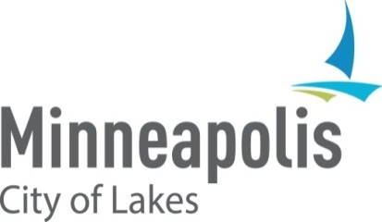

**2023 HUD Consolidated Annual Performance and Evaluation Report (CAPER) NOTICE OF PUBLIC HEARING**

## **When:** Tuesday, August 20, 2024, at 1:30 p.m. before the Business, Housing and Zoning (BHZ) Committee.

**Purpose:** To receive comment on the City’s Draft 2023 CAPER for CDBG, HOME, ESG, and HOPWA federal entitlement funding.

You are invited to comment on Minneapolis’ draft FY 2023 CAPER. The CAPER documents the City’s performance in its use of program year 2023 Community Development Block Grant (CDBG), HOME Investment Partnerships Program (HOME), Emergency Solutions Grants Program (ESG) and the Housing Opportunities for Persons with AIDS (HOPWA) federal entitlement funding. The draft Report can be viewed at <https://www2.minneapolismn.gov/government/departments/finance/grants-special-projects/consolidated-plan/> .

Written comments can be submitted to [matthew.bower@minneapolismn.gov](mailto:matthew.bower@minneapolismn.gov) from August 13, 2024 through August 27, 2024. Comments can also be provided at the public hearing. The City will be submitting the CAPER to the U.S. Department of Housing and Urban Development on August 29, 2024.

Information on how to participate in the public hearing can be accessed at the following website: <https://www.minneapolismn.gov/government/meetings/participate-in-a-meeting/> or by calling at 311 or 612-673-3000

For reasonable accommodations or alternative formats please contact Finance and Property Services at 612-673-3000 or via email at [finance@minneapolismn.gov](mailto:finance@minneapolismn.gov) . People who are deaf or hard of hearing can use a relay service to call 311 at 612-673-3000. TTY users call 612-263-6850. Para ayuda, llame al 311. Rau kev pab, hu 311. Hadii aad caawimaad u baahantahay, wac 311.