 Minneapolis Health Department

Canning at retail food businesses

# Canning hazards

The most common biological hazards when canning include botulism toxin, yeast, and mold (mycotoxins).

If you will be canning food at a retail food business, you must submit a Hazard Analysis Critical Control Point (HACCP) plan. Your plan must be approved before you begin canning.

All HACCP plans must include:

1. Information required on the [General HACCP Plan Checklist](https://www2.minneapolismn.gov/media/content-assets/www2-documents/business/HACCP-CONTENTS-CHECKLIST.pdf)
2. Bulleted items beneath the type of recipe, standard or custom, you are using

**The quickest and easiest way to can at retail is to use a standard recipe**. Standard recipes have been tested by the USDA and other agencies to make sure they are safe. If you are using a standard recipe you will not need to submit any additional testing data with your canning HACCP plan.

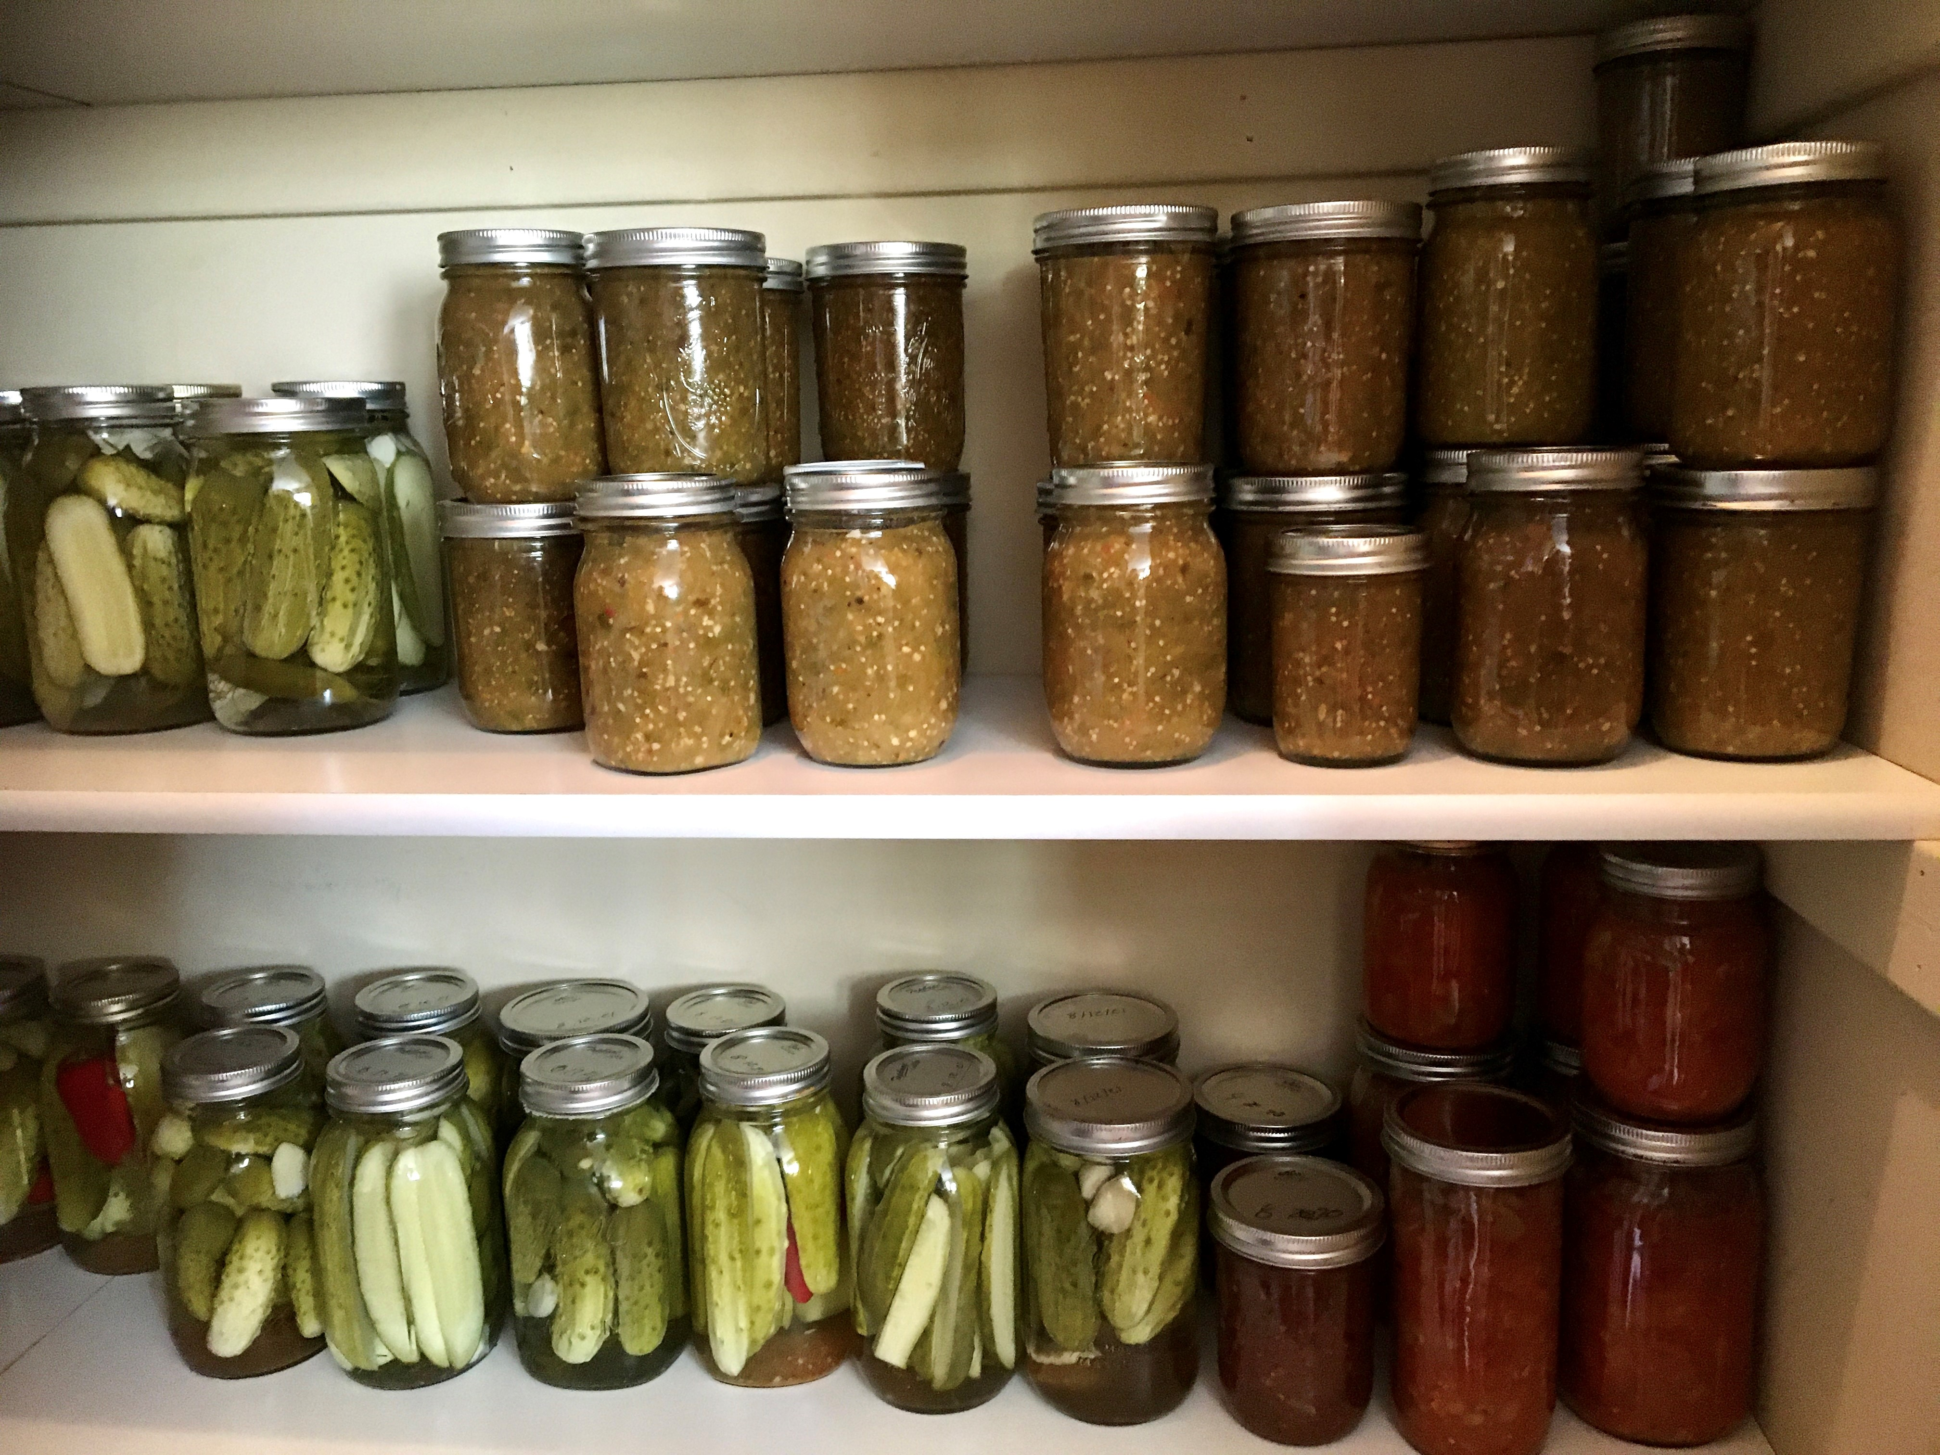Standard recipes

Standard recipes may be selected from the following sources:

* [USDA Complete Guide to Home Canning](https://www.nifa.usda.gov/about-nifa/blogs/usdas-complete-guide-home-canning)
* [National Center for Home Food Preservation](https://nchfp.uga.edu/#gsc.tab=0)
* Ball® Blue Book™

When using a standard recipe, you must follow the approved process for that recipe.

## Canning **with a standard** recipe:

* Provide a copy of the approved recipe
* Follow all CCPs from approved recipe
* Include container specifications and sterilization methods
* Include fruit and vegetable preparation procedures

# Custom recipes

You may use a custom process or recipe that is approved by a Processing Authority. A Processing Authority is a person or organization with expert knowledge of thermal processing requirements when canning and has access to a certified lab for testing recipes.

## Canning with a custom recipe

* Provide a copy of the custom recipe
* Include testing results from a process authority
* Include all CCPs as specified by process authority
* Include container specifications and sterilization methods
* Include fruit and vegetable preparation procedures

If you want to can low-acid foods, you must follow special requirements found in Code of Federal Regulations, title 21 (21 CFR). Low-acid foods include foods such as beans, corn, potatoes, squash and meats.

If you have questions about HACCP plans or canning requirements, email [HACCP@minneapolismn.gov](mailto:HACCP@minneapolismn.gov) or call 612-673-2301.

**[minneapolismn.gov/haccp](http://www.minneapolismn.gov/HACCP)**

For reasonable accommodations or alternative formats please contact Minneapolis Environmental Health at [health@minneapolismn.gov](mailto:health@minneapolismn.gov) or 612-673-2301. People who are deaf or hard of hearing can use a relay service to call 311 at 612-673-3000.   
TTY users can call 612-263-6850.

Para asistencia 612-673-2700, Yog xav tau kev pab, hu 612-673-2800, Hadii aad Caawimaad u baahantahay 612-673-3500.

[**http://www.minneapolismn.gov/FoodSafety**](http://www.minneapolismn.gov/FoodSafety)

For reasonable accommodations or alternative formats please contact Environmental Health at [health@minneapolismn.gov](mailto:health@minneapolismn.gov) or 612-673-2301. People who are deaf or hard of hearing can use a relay service to call 311 at 612-673-3000. TTY users call 612-263-6850.    
Para ayuda, llame al 311. Rau kev pab 311. Hadii aad Caawimaad u baahantahay wac 311.

Last updated October 2024